**DATA** metabolic;

input VisitType $ Rate;

DATALINES ;

nontrauma 13.9

nontrauma 15.4

nontrauma 15.8

nontrauma 17.9

nontrauma 18.3

nontrauma 19.9

nontrauma 20.6

nontrauma 21.4

nontrauma 21.7

nontrauma 23.1

trauma 20.0

trauma 20.6

trauma 24.0

trauma 25.1

trauma 26.2

trauma 30.0

trauma 30.6

trauma 30.9

trauma 33.8

trauma 44.1

;

**proc** **ttest** DATA= METABOLIC ci = equal;

class VisitType;

var Rate;

**run**;

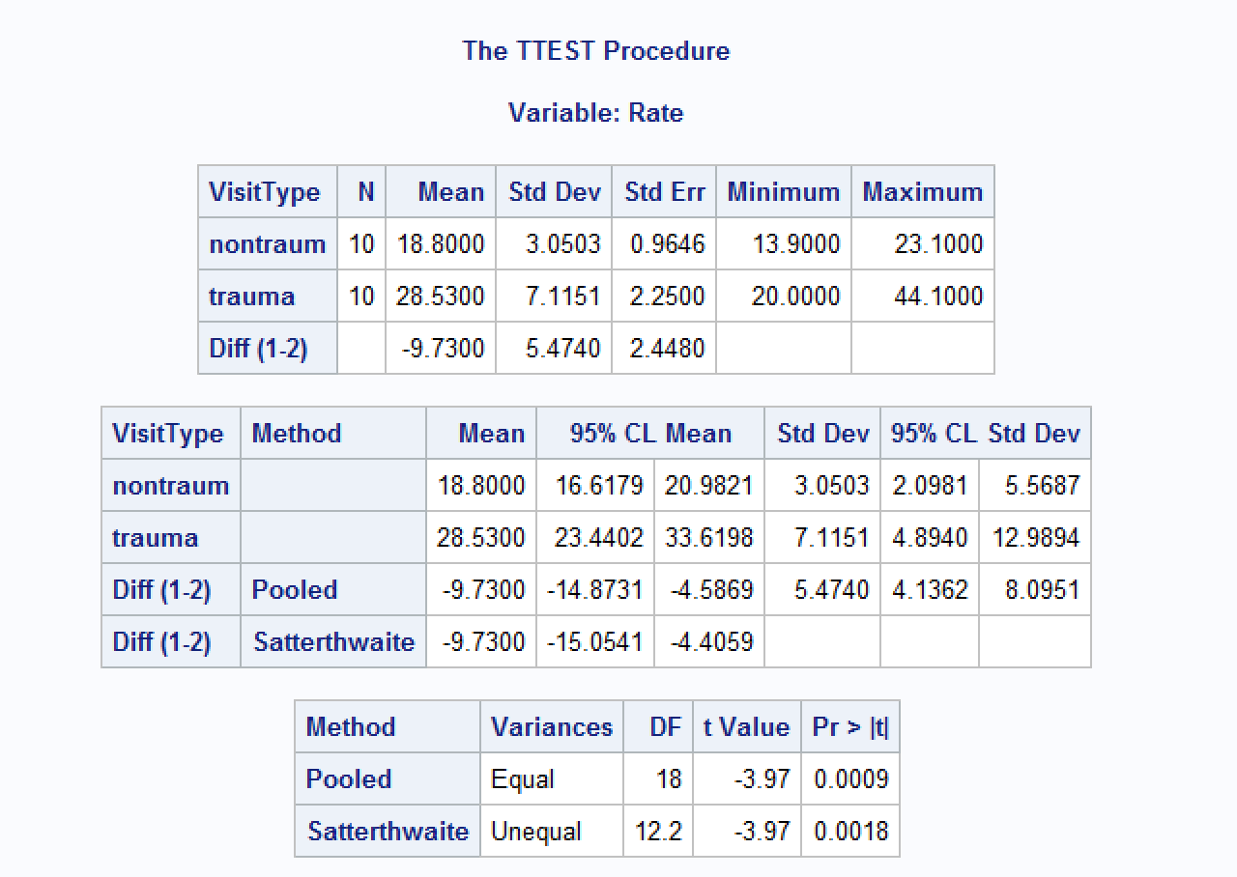

**b.**

**Proc** **MEANS** DATA = METABOLIC MEDIAN MEAN;

CLASS VISITTYPE;

VAR RATE;

**RUN**;

ORIGINAL RUN

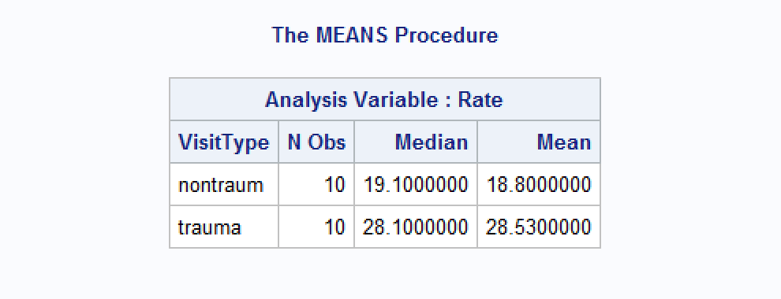

CODE:

**proc** **surveyselect** data=METABOLIC samprate=**0.50** out=RandTest1 outall method=srs noprint;

**run**;

**Proc** **MEANS** DATA = RANDTEST1 MEDIAN MEAN;

CLASS SELECTED;

VAR RATE;

**RUN**;

RUN 1

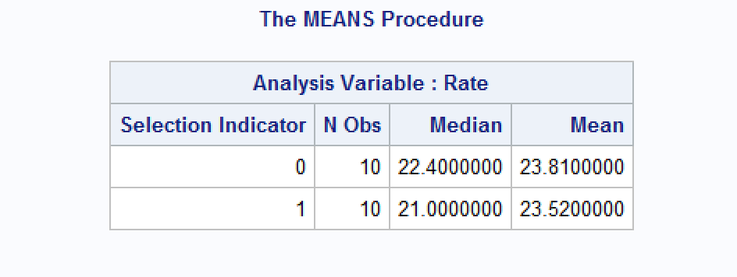

RUN 2

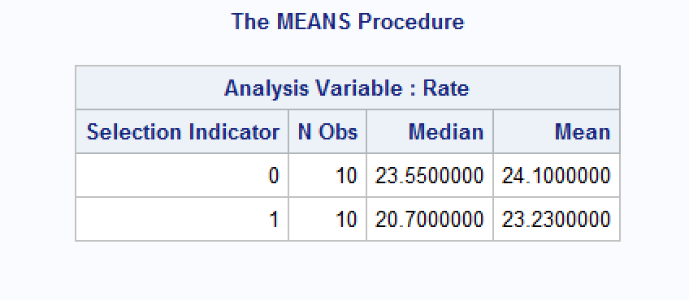

RUN 3

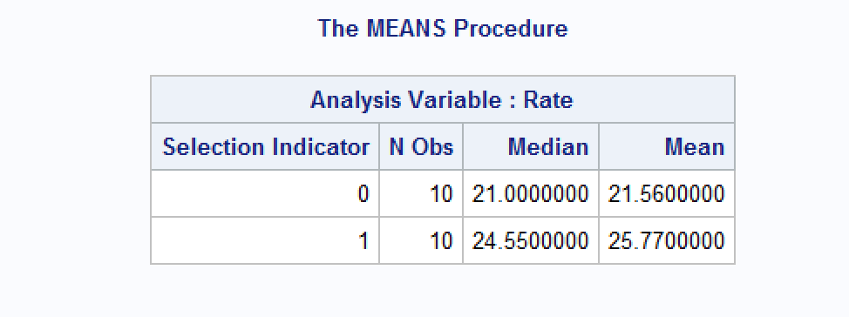

RUN 4

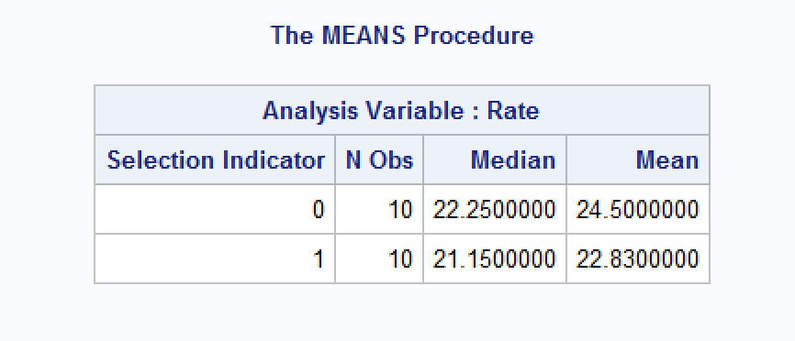

RUN 5

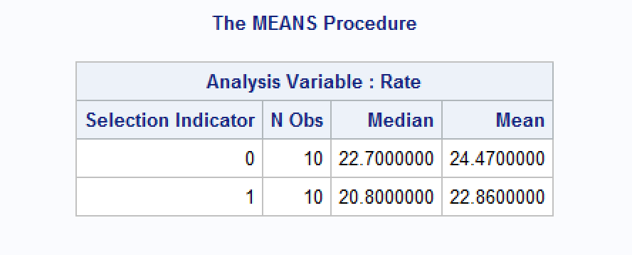

RUN 6

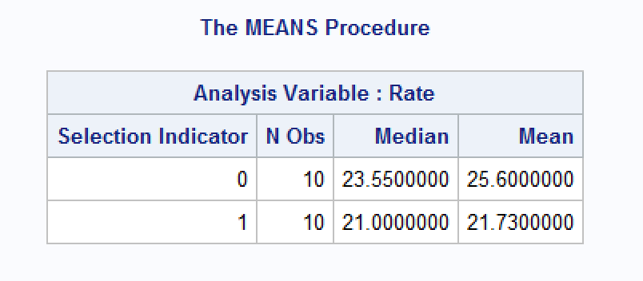

MEAN AND MEDIAN DIFFERENCES

|  |  |  |  |
| --- | --- | --- | --- |
|  | MEDIAN DIFF | MEAN DIFF | IS GREATER |
| ORIGINAL RUN | -9 | -9.73 |  |
| RANDOM RUN 1 | 1.4 | 0.29 | X |
| RANDOM RUN 2 | 2.85 | 0.77 | X |
| RANDOM RUN 3 | -3.55 | -4.21 | X |
| RANDOM RUN 4 | 1.1 | 1.67 | X |
| RANDOM RUN 5 | 1.9 | 1.61 | X |
| RANDOM RUN 6 | 2.55 | 3.87 | X |

RUNS GREATER THAN ORIGINAL = 6

RUNS / RUNS GREATER THAN ORIGINAL

6/6 = %99.999999

P-VALUE = .000001

If the non-trauma value was changed to 231 the median of the data set stays unaffected, but means (averages) are much less tolerate to large outliers. If you were comparing just the means it turns the entire test from 6/6 Random tests with greater means than the original to 0/6 Random tests with greater means than the original and creates a much higher p-value, but an incredibly low f-Stat.

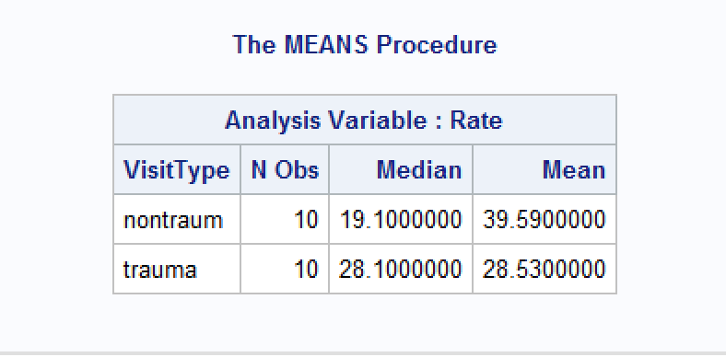

|  |  |  |  |
| --- | --- | --- | --- |
|  | MEDIAN DIFF | MEAN DIFF | IS GREATER |
| ORIGINAL RUN | -9 | 11.06 |  |
| RANDOM RUN 1 | 1.4 | 0.29 | 0 |
| RANDOM RUN 2 | 2.85 | 0.77 | 0 |
| RANDOM RUN 3 | -3.55 | -4.21 | 0 |
| RANDOM RUN 4 | 1.1 | 1.67 | 0 |
| RANDOM RUN 5 | 1.9 | 1.61 | 0 |
| RANDOM RUN 6 | 2.55 | 3.87 | 0 |

